Experiment No. 2
1. Title: Use var, let, const, and demonstrate basic features like template literals and destructuring build a billing calculator with user input.
2. Software/Tools Required:
- Visual Studio Code (VS Code)
- Google Chrome
- HTML5
- JavaScript
3. Theory: JavaScript is a client-side scripting language used to make web pages interactive and dynamic. It can be included in an HTML document in three ways:
Variables (var, let, const ) :
- Var : The traditional way to declare variables. It is function-scoped and hoisted.
- Let : Introduced in ES6, it is block-scoped, meaning it only exists within the {} block where it is defined.
- const: Also block-scoped, used for declaring constants whose values cannot be reassigned.
The script captures the text and numeric inputs using var, performs a validation check to block empty or negative values, and bundles the inputs into a unified configuration object. It then uses Object Destructuring to extract individual properties effortlessly into const values, calculates the respective tax and net totals using mutable let variables, and dynamically constructs a clean data block using Template Literals. Finally, it hides the initial screen placeholder and seamlessly prints the live tax invoice on the right side of the layout.

4. Output:
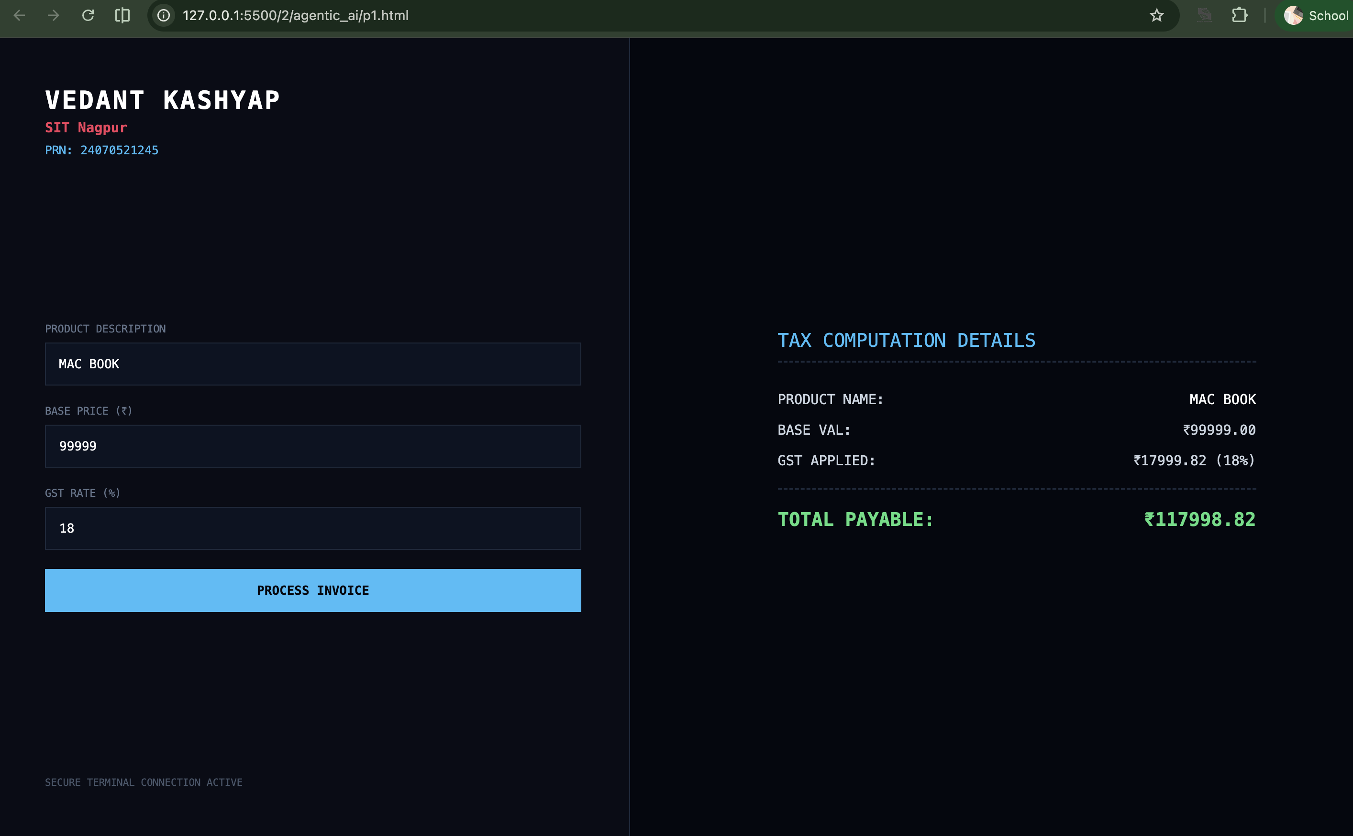

5. Result/Conclusion:
The dynamic billing calculator application was successfully constructed. Through this experiment, fundamental modern JavaScript programming structures (including variable scope boundaries via var, let, and const, shorthand array/object data parsing through destructuring, and string interpolation via template literals) were cleanly integrated with standard user-input HTML structures.

